**Standard Operating Procedure (SOP) for the Data Pipeline Streamlit Application**

**1. Introduction**

The Data Pipeline Streamlit Application is a web-based tool that allows users to Run the data pipeline and also we can check the student journey for quiz marks, Incubator timing, summary of student, watch time of student. This document outlines the procedures for using and maintaining the application.

**2. Purpose**

The purpose of this SOP is to guide users on how to use the Data Pipeline Streamlit Application and ensure consistent usage across different users.

**3. Scope**

This SOP applies to all users who interact with the Data Pipeline Streamlit Application.

**4. Responsibilities**

**Users:**

* User can run all python code through GUI by selecting which program they want to run by clicking on Run Data Pipeline button.
* User can go to output folder; source folder and code folder directly from our GUI. It will redirect to specific chosen folder of selected program.
* User can go to power bi dashboard once it click on Go To Power BI and after that they will see Open power BI Dashboard after clicking on it they will redirect to Power BI visualization. The Button can be seen in Home and Summary Side bar and at top of Data Pipeline page.
* User Can see the student journey by various pages provided inside bar such as

1. Incubator: Here user can get information about video watch time. User can select or type mail id inside bar of student user want to find then all information of student will appear on dashboard. From there user can get all, specific week or specific session watch time.
2. Quiz: Here user can get information quiz marks. User can select or type mail id inside bar of student user want to find then all information of student will appear on dashboard. From there user can get all marks of quiz he or she has taken. User can also choose the specific quiz to see marks of particular quiz test. User can also see the overall ranking of that student. For visualization we have plot a graph to easy comparison of student’s marks.
3. Assignment: Here user can get information about student marks and comment for selected assignment. User can select or type mail id in side bar of student user want to find then all information of student will appear on dashboard. From there user can get marks and comment of selected assignment.
4. Overall: Here user can get information overall information about student. User can select or type mail id in side bar of student user want to find then all information of student will appear on dashboard. From there he/she can choose column they want to explore.

**Developers:**

* Developers are responsible for maintaining and updating the application code to ensure smooth functionality.
* Developers must ensure the accuracy and integrity of the data available in the application.
* To run the program, we have to click on .bat file.
* We have created two GUI i.e., SQL and CSV

1. SQL: Basically, here our source file for dashboard is MySQL database that is in our VS Data Laptop. It is done because here we get information of all courses we have done till data.
2. CSV: Here our source is csv file. We have taken source file as csv because we can find it in every laptop of our VigyanShaala team. So, we can put our Gui in every laptop needed.

**5. Procedure**

**Step 1: Launching the Application**

* Method 1: We can Direct-click on the GUI. bat file. We can also create a shortcut to that file and keep it on our desktop, so whenever we click on it, we will open our GUI.

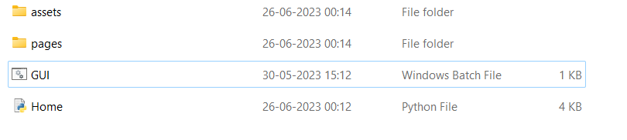

* Method 2: Locate the Streamlit application script and execute it using the Python interpreter.

1. Go to the location of your application, and in the path, type cmd and press enter.

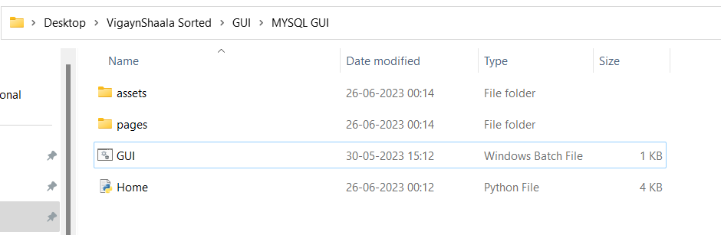



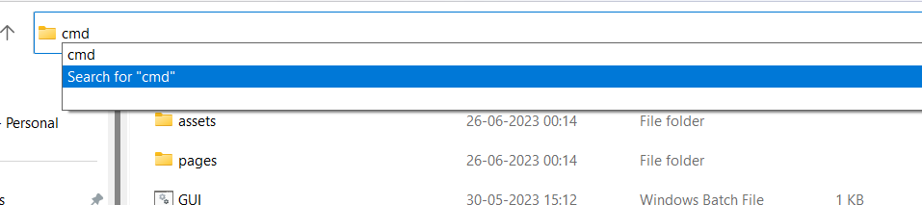

1. Then a black command prompt will be seen. In that type Streamlit run Home.py (Home.py is your main file of python) and press enter. Then your Gui home page will be visible.

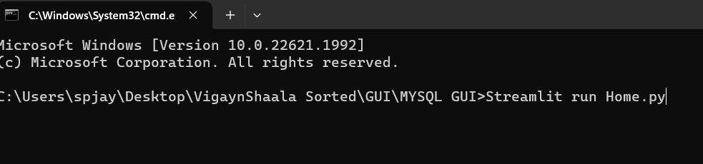

**Step 2: Home Page**

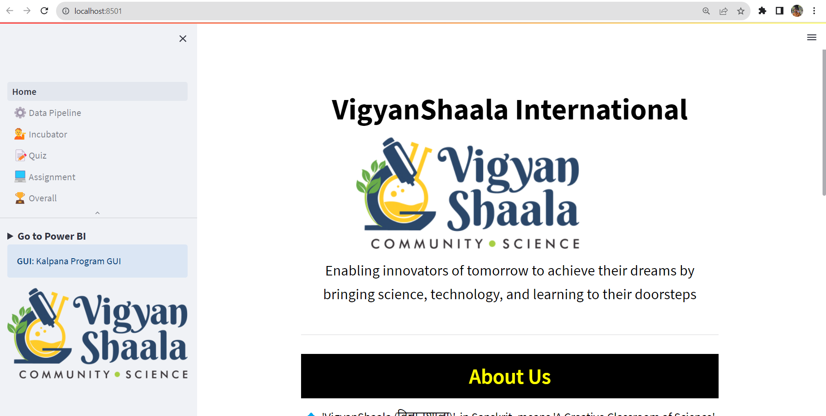

* After launching the application, the Home Page will be displayed. There you will get all information of VigyanShaala.
* In Sidebar you will see pages like Data Pipeline, Incubator, Quiz, Assignment and Overall.
* Click on pages you want to explore. And form ***Go to Power BI*** you can go to see power bi dashboard.

.

**Step 3: Exploring all pages**

1. Data pipeline

**Running Python Code through GUI:**

* 1. Open the GUI interface.
  2. Look for the "**Run Data Pipeline**" button and click on it.
  3. A list of available programs will be displayed.
  4. Select the desired program you want to run by clicking on it.
  5. The selected program's code will be executed, and you'll see the output within the GUI.

**Navigating to Folders:**

* Inside the GUI, find options related to folders (Output, Source, and Code folders).
* Click on the respective folder option you want to navigate to (Output, Source, or Code).
* After clicking, the GUI will redirect you directly to the chosen folder.

**Accessing Power BI Dashboard:**

* 1. Locate the "Go To Power BI" button within the GUI.
  2. Click on the "Go To Power BI" button.
  3. After clicking, you will be directed to the Power BI dashboard page.
  4. Look for the "Open Power BI Dashboard" button on the Power BI page.
  5. Click on the "Open Power BI Dashboard" button to access the Power BI visualization.

**Placement of Power BI Button:**

* The "Go To Power BI" button can be found in two places: the Home page and the Summary Side bar.
* Additionally, you might also see the "Go To Power BI" button at the top of the Data Pipeline page.

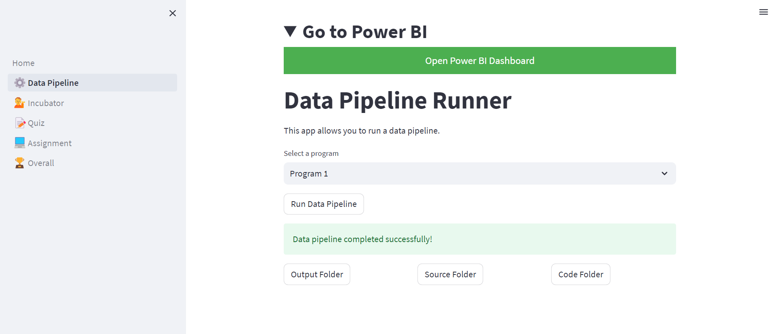

1. Incubator

**Viewing Video Watch Time Information:**

* Access the GUI interface.
* Look for the page ‘Incubator’ in sidebar.
* In the sidebar, there should be an option to either select a student from a list or manually type in a student's email ID.
* Select the student whose video watch time information you want to view, or enter their email ID in the provided field.

**Displaying Student Information:**

* Once you've selected a student or entered their email ID, the dashboard will populate with the student's information.
* The information displayed may include the student's name, email ID, enrolled courses, and other relevant details.

**Accessing Video Watch Time Details:**

* On the student's dashboard, you should see options to view video watch time information.
* There might be tabs or buttons to show different categories of watch time data, such as "Weekly", or "Specific Session".

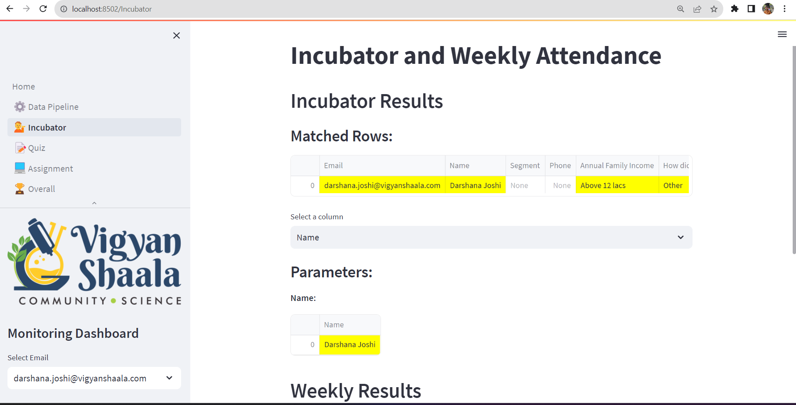

1. Quiz

**Viewing Quiz Marks and Information:**

* Open the GUI interface.
* Look for the section related to "Quiz" in sidebar.
* In the sidebar, find an option to select a student from a list or manually input a student's email ID.
* Select the student whose quiz marks and information you want to view or enter their email ID in the provided field.

**Displaying Student Information:**

* Once you've selected a student or entered their email ID, the dashboard will populate with the student quiz marks.
* There you will also see student ranking and graph of student marks for visualization.

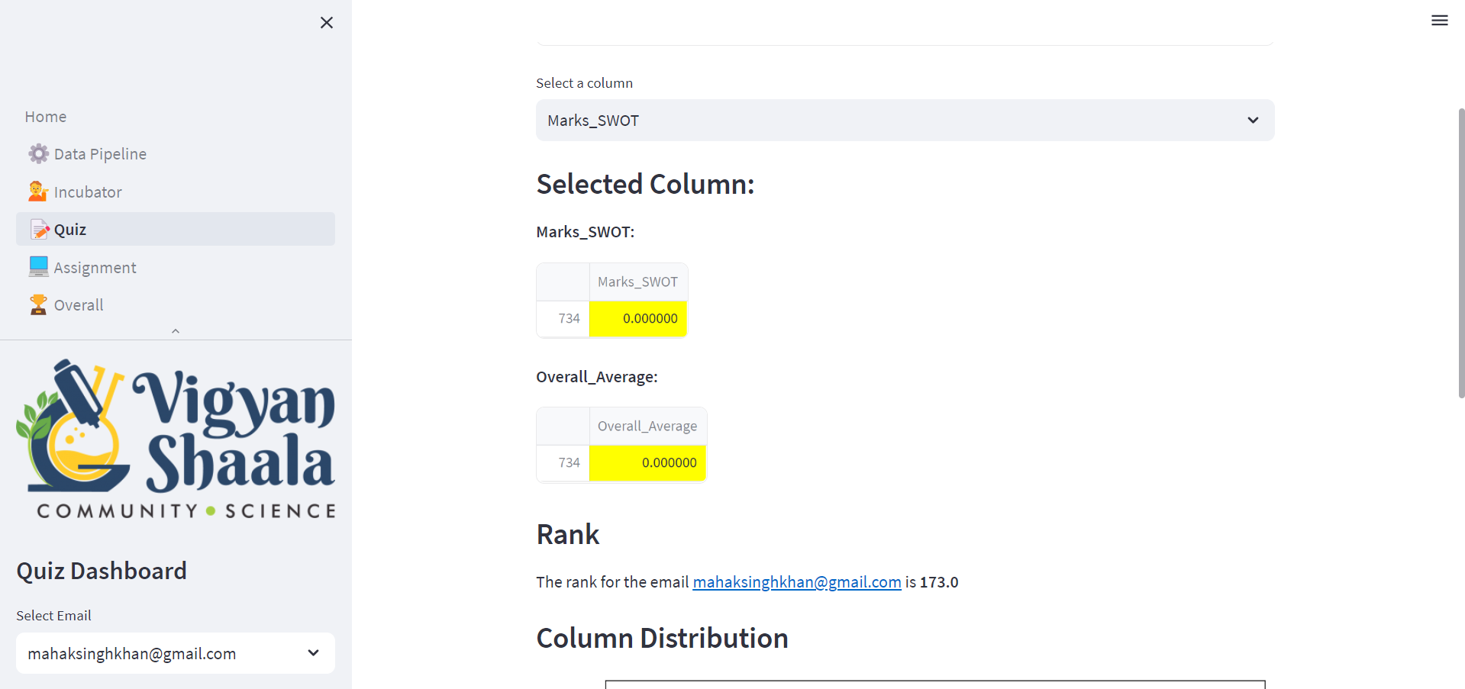

1. Assignment

**Select Student and Display Assignment Information:**

* Users open the GUI interface.
* Look for the section related to "Quiz" in sidebar.
* In the sidebar, users either select a student from a list or manually input a student's email ID.
* The dashboard populates with the chosen student's Assignment details.

**Viewing Assignment Marks and Comments:**

* Within the student's dashboard, users find sections related to "Assignment Marks" and "Comment".

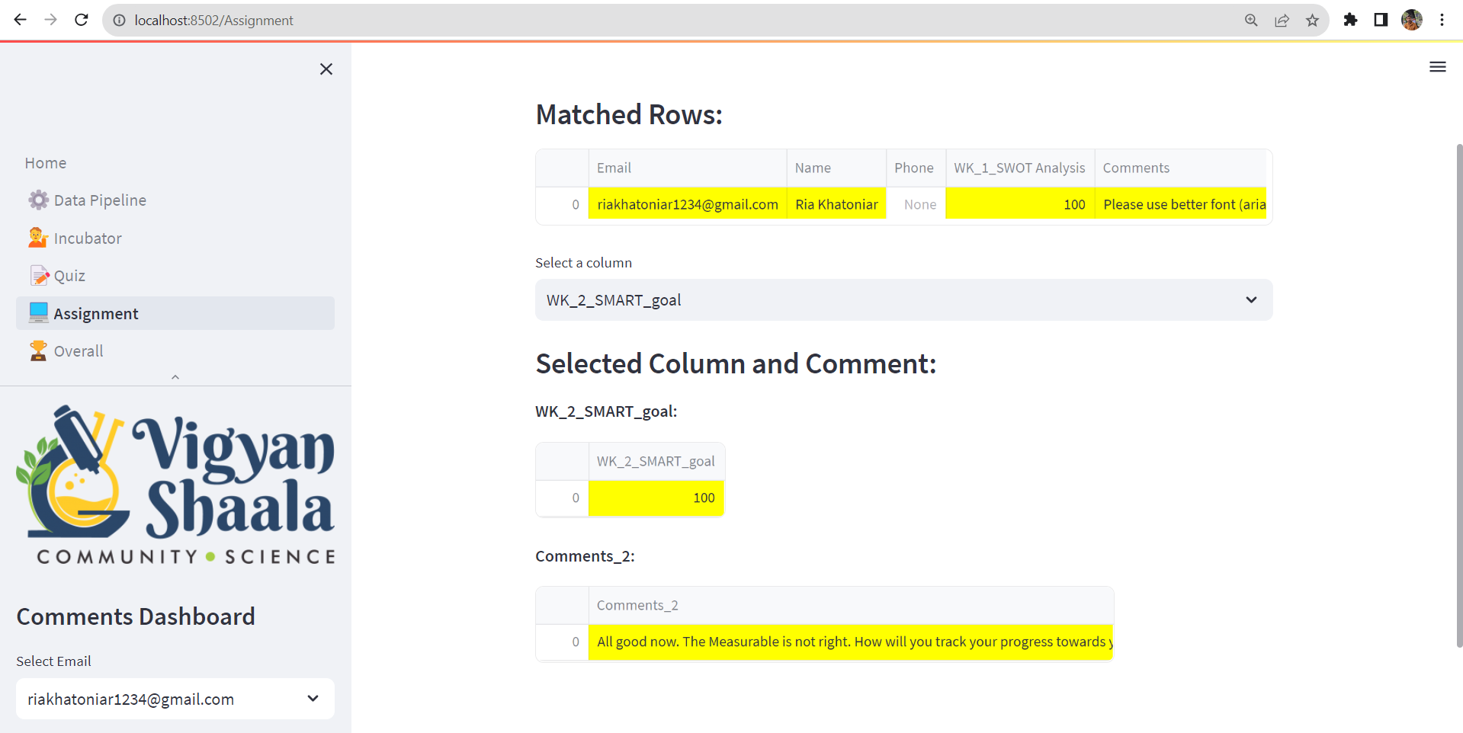

1. Overall

Here, users can get general information about students. User can select or type the mail id in the side bar of the student they want to find, and then all information about the student will appear on the dashboard. From there, he or she can choose the column they want to explore like Recorded Videos- Percentage WatchTime per Week (%), Time Spent on Video content (Hours), etc.

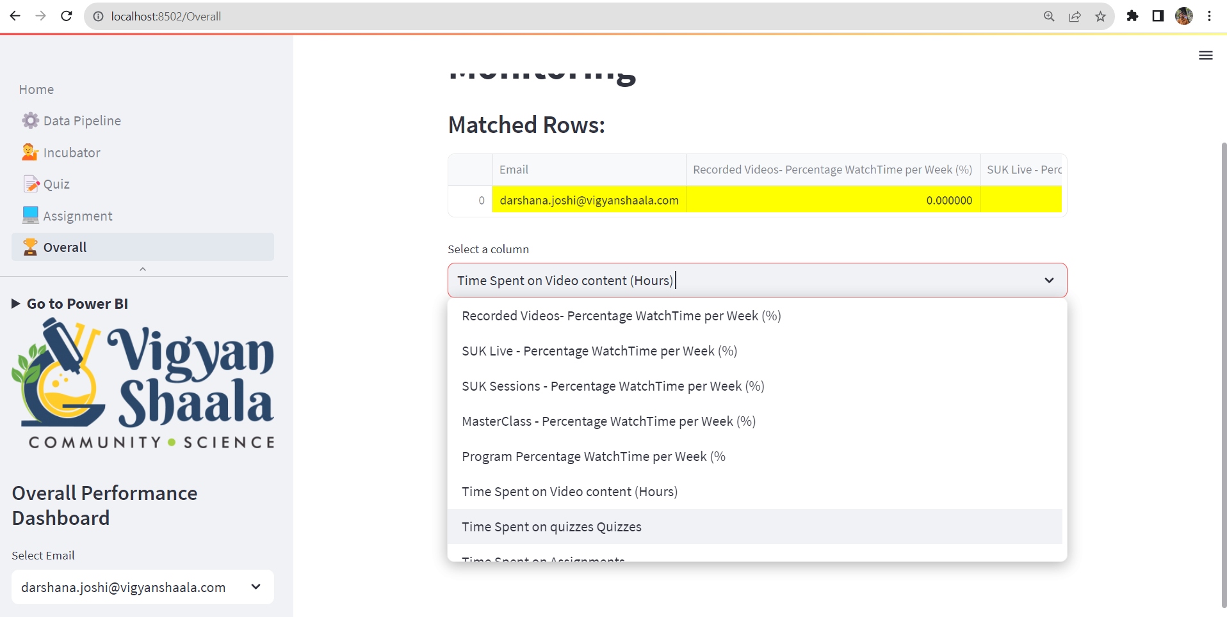

**6. Conclusion**

This SOP provides guidance on how to use the Data Pipeline Streamlit Application effectively. By following these procedures, users can access college-related information and make informed decisions about their educational aspirations.

**7. References**

* Streamlit Documentation: [streamlit.io/docs](https://streamlit.io/docs)
* pandas Documentation: [pandas.pydata.org/docs](https://pandas.pydata.org/docs)